

UNIVERSITY OF AZAD JAMMU & KASHMIR
Department of Software Engineering
Software Configuration Management Technologies (SCMT)

Lab No.6

Submitted by | - Name: Rizwan Ali  - Roll No: 2025-SET-40
Submitted To | - Eng. Fahad Nisar
Degree Program | - BSc Software Engineering Technology
Submission Date | - 2 June 2026

Lab Objective: Creating a GitHub Repository and Cloning a Public Repository

Step 1 Create and Push Code to Main Branch

In this step, I created the main-file.txt file in my project folder. After creating the file, I added it to the Git staging area, committed the changes, renamed the branch to main, and pushed the code to the GitHub repository.
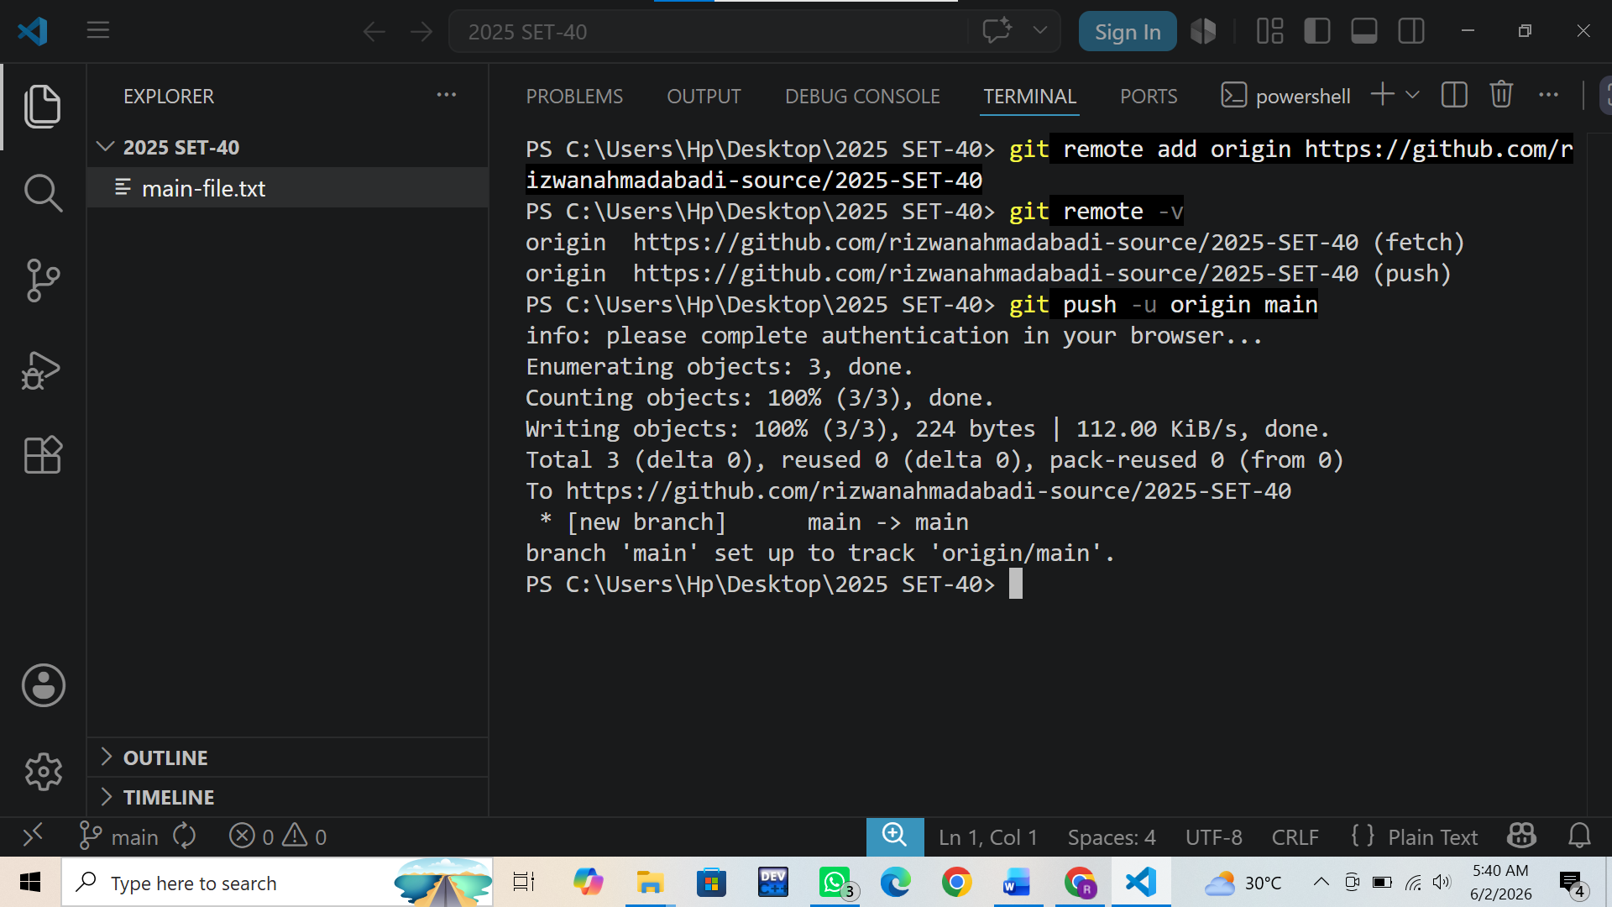

Commands Used:
- git add .
- git commit -m "Add main-file.txt"
- git branch -M main
- git push -u origin main

Step 2 Create and Push Feature Branch
In this step, I created a new branch named feature-branch, added a new file, committed the changes, and pushed the branch to GitHub.

Commands Used:
- git checkout -b feature-branch
- git add .
- git commit -m "Add feature-file.txt on feature-branch"
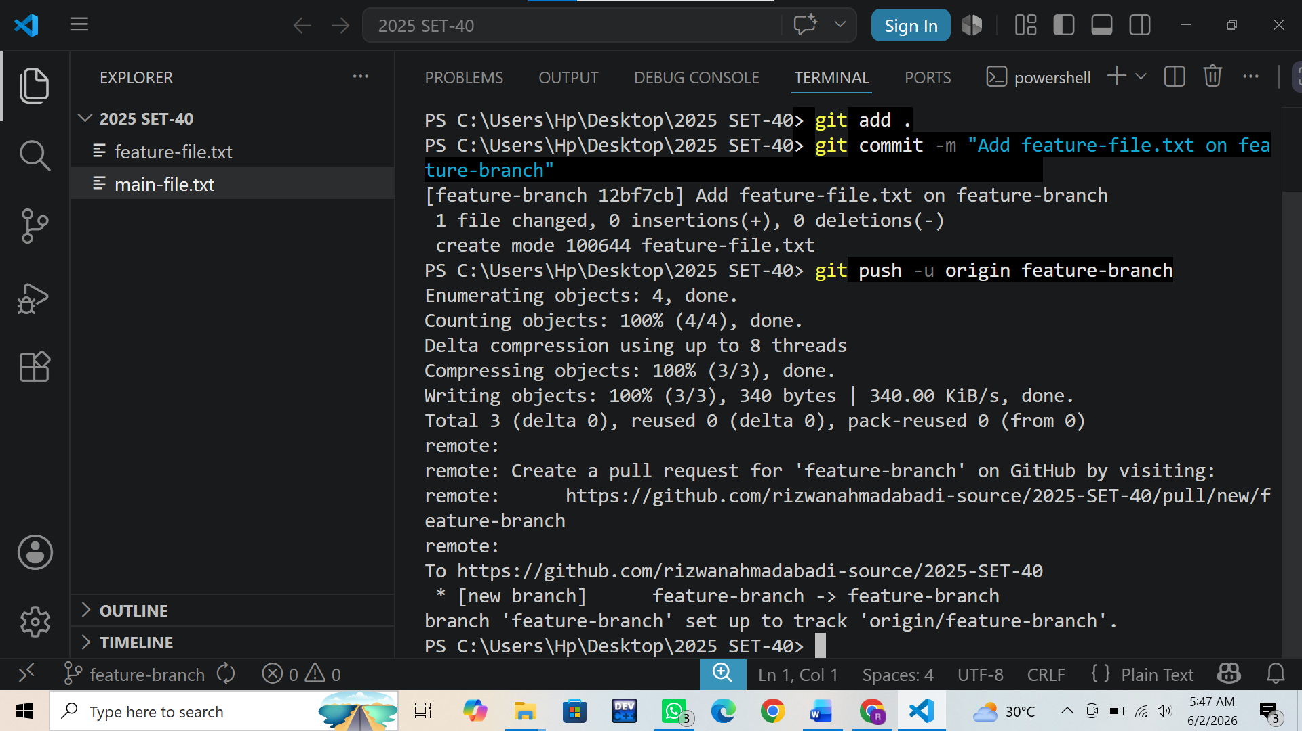
- git push -u origin feature-branch
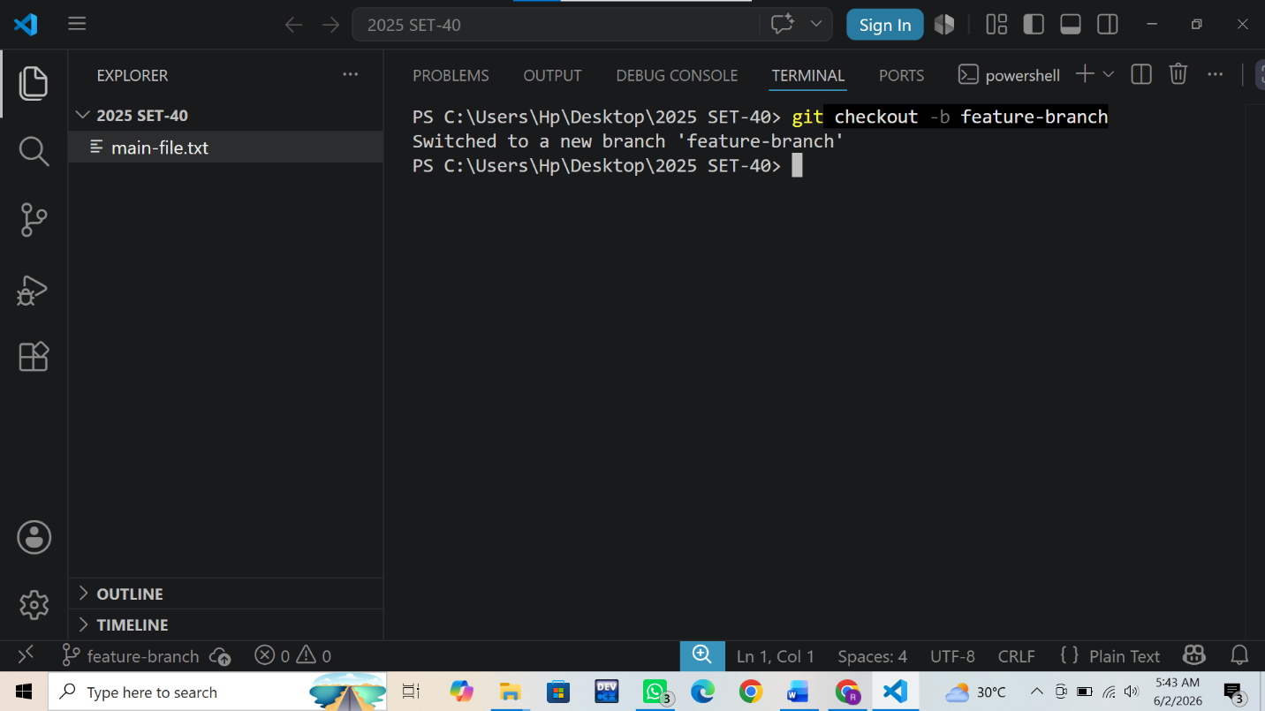

Step 3. Verify Branches on GitHub
In this step, I verified that both branches were available on GitHub and confirmed that the changes were successfully pushed.

Commands Used:
- git branch
- git log --oneline –all
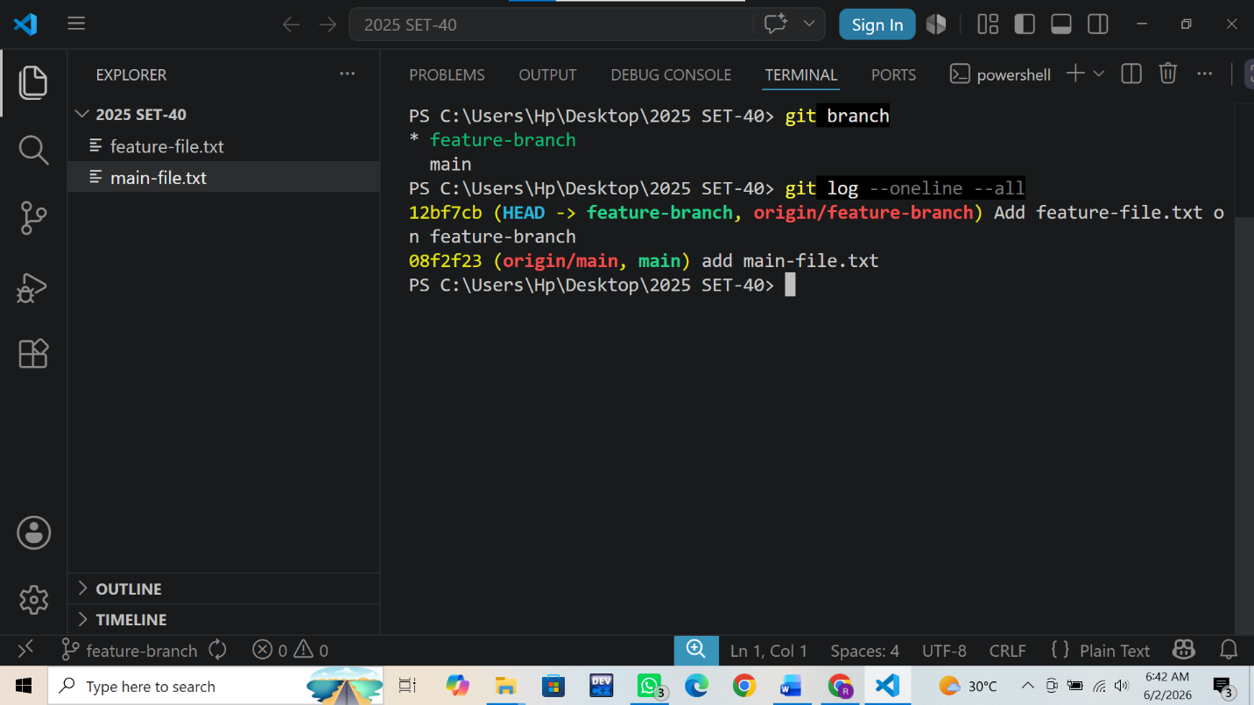

And I also visited my GitHub repository and verified that both branches (main and feature-branch) were successfully created and available on GitHub. I checked the branch dropdown menu to switch between branches and confirmed that the files had been pushed successfully. This verification ensured that the repository contained the required branches and commits.

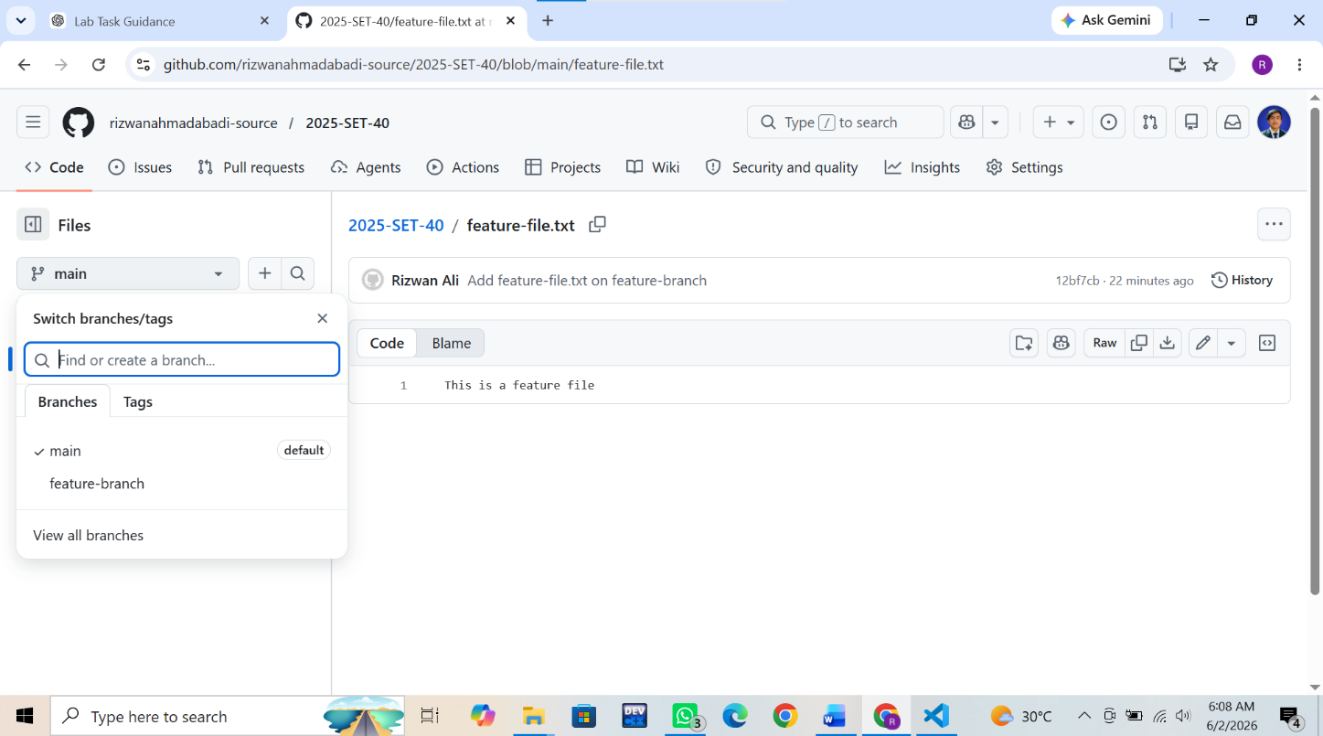
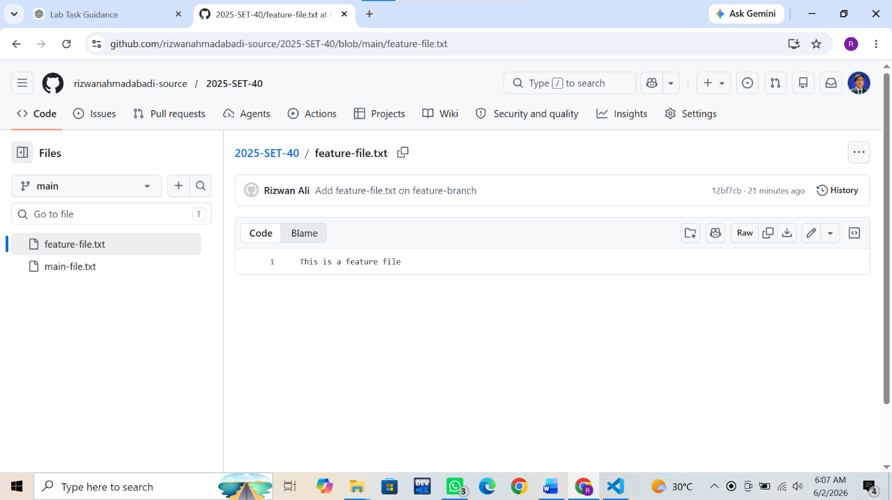
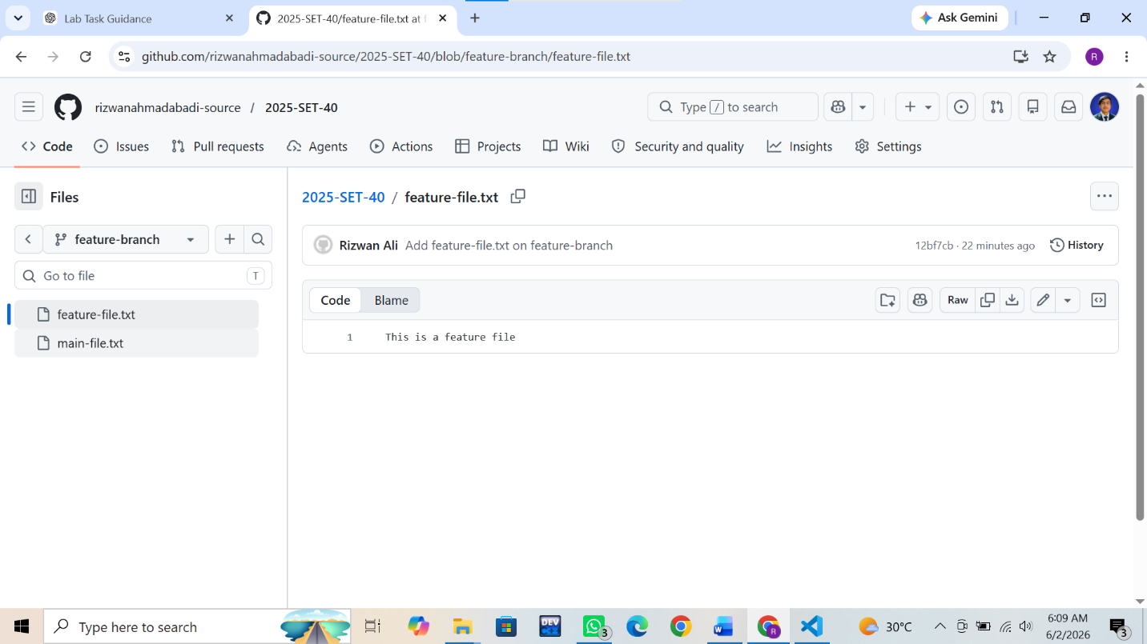
Conclusion
This lab task provided practical experience with Git and GitHub version control operations. I learned how to create a local repository, track changes using commits, push code to a remote GitHub repository, create and manage branches, and verify branch availability on GitHub. The task improved my understanding of branch-based development and demonstrated how GitHub can be used to organize and manage project versions efficiently.

